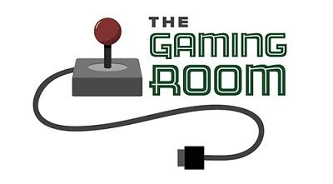

Draw It Or Lose It

CS 230 Project Software Design Template
Version 1.0

Table of Contents

CS 230 Project Software Design Template 1
Table of Contents 2
Document Revision History 2
Executive Summary 3
Requirements 3
Design Constraints 3
System Architecture View 3
Domain Model 3
Evaluation 4
Recommendations 5

Document Revision History

Version | Date | Author | Comments
1.0 | 05/21/2026 | Domenic Ferraro | Added Executive Summary and Design Constraints.
1.0 | 06/02/2026 | Domenic Ferraro | Added Evaluation.
1.0 | 06/18/2026 | Domenic Ferraro | Added Recommendations.

Instructions
Fill in all bracketed information on page one (the cover page), in the Document Revision History table, and below each header. Under each header, remove the bracketed prompt and write your own paragraph response covering the indicated information.

Executive Summary

The client, The Gaming Room, wants to develop a web-based game that runs on multiple platforms, based on their current game, Draw It or Lose It, which is currently Android-only. Their goal is to create a scalable, secure, and maintainable application that allows users on different platforms and devices to play the game through a web browser.
The client requests the following for their application.
- A game can have one or more teams.
- Each team will have multiple players assigned to it.
- Game and team names must be unique to allow users to check whether a name is in use when choosing a name.
- Only one instance of the game can exist in memory at any given time.
To meet these requirements, the proposed solution is to develop the application using object-oriented programming and client-server architecture. A web-based design will improve accessibility across platforms without requiring separate applications for each operating system. The design will also use a singleton pattern to ensure that only one instance exists in memory, with unique identifiers to manage games, teams, and players.
The system should be designed for scalability. Since the application will support multiple concurrent users, the software must provide reliable server performance, efficient memory management, and secure interactions. Web-based architecture also simplifies future updates and maintenance because changes can be deployed centrally rather than on user devices.

Requirements

The client’s business requirement is to expand their existing Android-only game, Draw It or Lose It, into a web-based application that can be accessed across multiple platforms. The client wants users on operating systems such as Windows, macOS, Linux, Android, and iOS to be able to access the game through a web browser without requiring separate versions of the application for each platform. This approach will increase accessibility, simplify maintenance, and reduce development costs.

The client’s technical requirement is that their current experience is limited to Android application development. Because of this limitation, they require guidance in selecting appropriate software architecture, development tools, server environments, and programming practices that support cross-platform compatibility and scalability. The application must also support multiple teams and players, maintain unique names for games and teams, and ensure that only one active game instance exists in memory at a time through the use of proper object-oriented design patterns such as the singleton pattern.

Design Constraints

Several design constraints must be considered when developing Draw It Or Lose It as a web-based application. Because the game will be operated across multiple platforms and devices, the application must support compatibility with different operating systems, browsers, and hardware. All this means that the software should rely on web technologies rather than platform-specific features.

Another design constraint is the distributed client-server environment. The game data and logic will be hosted on a centralized server while users access the game remotely through web browsers. This requires reliable network communication, server-side processing, and synchronization between users. The development team must consider latency, bandwidth usage, and server scalability to maintain consistent performance.

Security is also an important design constraint. Since multiple users will access the application online, the system must protect their data and prevent unauthorized access. This requires secure authentication methods, controlled server access, and correct handling of the game sessions and stored information.

Database and memory management constraints exist due to the requirement of having unique games and team names. The application must maintain accurate records of existing names and validate new entries efficiently. The requirement that only one game instance exists in memory at any one time affects software architecture and requires implementation of the singleton design pattern.

The client’s limited experience with non-Android development also creates a technical constraint. The selected technologies and architecture should be easy to maintain and well-documented for future updates and support. Using well-known programming languages and frameworks, and keeping to good practice, will help reduce development complexity and improve maintainability.

System Architecture View

Please note: There is nothing required here for these projects, but this section serves as a reminder that describing the system and subsystem architecture present in the application, including physical components or tiers, may be required for other projects. A logical topology of the communication and storage aspects is also necessary to understand the overall architecture and should be provided.

Domain Model

The UML class diagram for Draw It Or Lose It represents the domain model of the application and illustrates how the classes interact within the system. The diagram demonstrates the relationships between the main entities of the game, including the game service, games, teams, and players. It also shows how object-oriented programming principles are used to organize the application efficiently and meet the client’s software requirements.
The Entity class serves as the base class for the Game, Team, and Player classes. It contains common attributes such as id and name, along with methods like getId(), getName(), and toString(). This demonstrates the object-oriented principle of inheritance because the child classes inherit shared properties and behaviors from the parent Entity class. Using inheritance reduces duplicated code and improves maintainability by centralizing common functionality in one location.
The Game class contains a list of Team objects, showing that a game can have multiple teams associated with it. Likewise, the Team class contains a list of Player objects, representing that each team can have multiple players. These relationships fulfill the software requirement that games contain one or more teams and that teams contain multiple players. The multiplicity notation of 0..* (zero to many) further illustrates that multiple objects can exist within these relationships.
The GameService class acts as a central manager for the application. It stores collections of games and maintains unique identifiers for games, teams, and players using variables such as nextGameId, nextTeamId, and nextPlayerId. This class also includes methods for adding and retrieving games. The GameService class demonstrates encapsulation because it controls access to the game data and provides methods that manage the creation and retrieval of objects instead of allowing direct access to the internal data structures.
The diagram also demonstrates the singleton design pattern through the GameService class. The attribute service and the method getInstance() indicate that only one instance of GameService can exist at a time. This satisfies the requirement that only one game service instance exists in memory during execution. The SingletonTester and ProgramDriver classes are used to test and demonstrate this functionality.
Polymorphism is also present because the child classes (Game, Team, and Player) inherit methods from the Entity class and may provide specialized implementations if needed. This supports flexibility and scalability as the application grows.
Overall, the UML diagram effectively models the relationships and responsibilities of the system while applying object-oriented principles such as inheritance, encapsulation, polymorphism, and the singleton pattern. These principles help create a scalable, maintainable, and efficient web-based game application that fulfills the client’s software requirements.

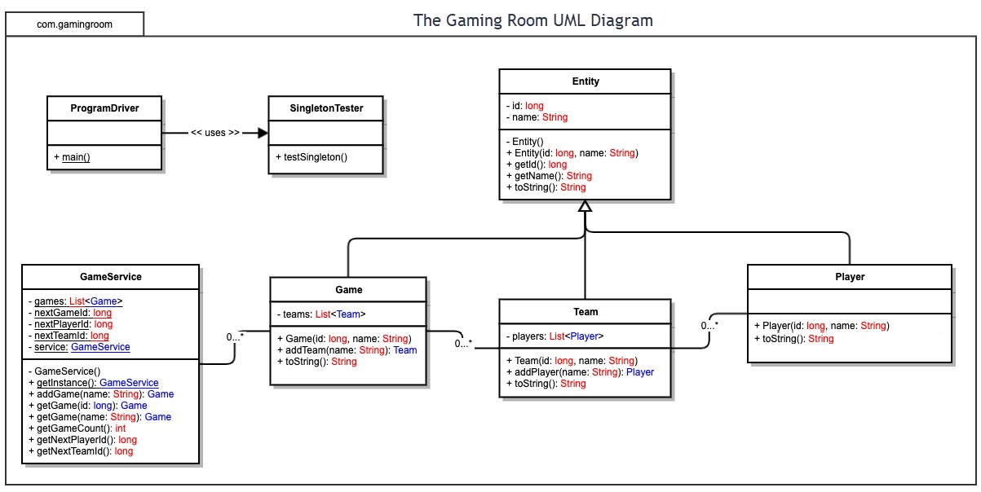

Evaluation

Using your experience to evaluate the characteristics, advantages, and weaknesses of each operating platform (Linux, Mac, and Windows) as well as mobile devices, consider the requirements outlined below and articulate your findings for each. As you complete the table, keep in mind your client’s requirements and look at the situation holistically, as it all has to work together.

In each cell, remove the bracketed prompt and write your own paragraph response covering the indicated information.

Development Requirements | Mac | Linux | Windows | Mobile Devices
Server Side | macOS can host web applications using Apache, Nginx, Java, and other web technologies. It provides a stable UNIX-based environment and strong security features. However, macOS Server is no longer widely used for enterprise-scale web hosting, and Apple hardware can increase deployment costs. Licensing costs are generally higher because Apple requires macOS to run on Apple hardware. While suitable for development and small deployments, it is not the most cost-effective option for hosting a large-scale game supporting thousands of users. | Linux is the preferred platform for hosting large-scale web applications. It supports Apache, Nginx, Tomcat, Docker, and cloud environments while offering excellent stability, security, and scalability. Most Linux distributions are open source with little or no licensing cost, making them highly cost-effective. Linux is widely used in enterprise and cloud hosting environments and is well-suited for supporting thousands of concurrent players. Its primary weakness is that administration may require greater technical expertise. | Windows Server supports web hosting through IIS, .NET, Java, and other server technologies. It provides a user-friendly administrative interface and strong integration with Microsoft products. However, Windows Server licenses can be expensive, especially when scaling across multiple servers. It generally requires more system resources than Linux. Windows is a viable hosting platform, but it may increase operational costs compared to Linux. | Mobile devices are not appropriate platforms for hosting a web-based application. Smartphones and tablets lack the processing power, reliability, storage capacity, and network infrastructure required to support thousands of concurrent users. Mobile platforms should function only as clients that connect to a centralized server. Therefore, hosting costs are not applicable, and mobile devices should not be considered for server deployment.
Client Side | Supporting macOS clients requires testing across major browsers such as Safari, Chrome, and Firefox. A responsive HTML5 web interface minimizes platform-specific development, reducing overall cost and development time. Developers must understand browser compatibility and user interface design. Because the application runs in a browser, no separate macOS application is required. | Linux users access the application through web browsers, reducing platform-specific development requirements. Development teams must test browser compatibility across multiple Linux distributions and browsers. Costs remain relatively low because the same web-based code can be used across platforms. Expertise in web standards and browser testing is necessary. | Windows clients can access the application through common browsers such as Chrome, Edge, and Firefox. Since Windows represents a large portion of desktop users, extensive testing is required to ensure compatibility. A responsive browser-based interface reduces development effort compared to creating a native Windows application. Development costs focus primarily on browser testing and quality assurance. | Mobile devices require responsive design techniques to support varying screen sizes and touch-based interfaces. The application must be tested on both Android and iOS browsers to ensure consistent performance. Development costs and testing time increase because of the large number of device types, operating system versions, and screen resolutions. Expertise in responsive web design and mobile usability is required to provide a quality user experience.
Development Tools | Development can be performed using Java, JavaScript, HTML5, CSS, and frameworks such as Spring Boot or Node.js. Popular tools include IntelliJ IDEA, Eclipse, Visual Studio Code, Git, and Docker. Most tools are available on macOS, although Apple hardware increases overall development costs. Specialized macOS expertise may be needed for testing Safari compatibility. | Linux supports Java, JavaScript, HTML5, CSS, Python, and numerous open-source frameworks. Common tools include IntelliJ IDEA, Eclipse, Visual Studio Code, Git, Docker, Kubernetes, Apache, and Nginx. Most development tools are free or open source, minimizing licensing costs. Linux is highly flexible but may require team members with stronger command-line and server administration skills. | Windows supports Java, JavaScript, HTML5, CSS, .NET, and many web frameworks. Common tools include Visual Studio, Visual Studio Code, Eclipse, IntelliJ IDEA, Git, and Docker Desktop. Some Microsoft development tools may require licensing fees. Development teams familiar with Microsoft technologies can be productive quickly, although costs may be higher than Linux-based environments. | Mobile development primarily relies on HTML5, CSS, JavaScript, responsive design frameworks, browser testing tools, and mobile emulators. Android Studio and Xcode may be used for testing, even though the application is web based. Additional testing tools increase development effort, and expertise is required to validate functionality across Android and iOS platforms. A dedicated quality assurance effort may be necessary to ensure consistent performance on a wide range of devices.

Recommendations

Analyze the characteristics of and techniques specific to various systems architectures and make a recommendation to The Gaming Room. Specifically, address the following:

- Operating Platform: Linux is the recommended operating platform for The Gaming Room, especially systems such as Ubuntu Server or Red Hat Enterprise. Linux is the industry standard for hosting scalable web applications because of its excellent performance, reliability, security, and flexibility. Linux also supports Java-based applications used in this project, integrates with cloud-hosted environments, and has low operating costs due to its open-source licensing model. Linux will enable The Gaming Room to support users on Windows, macOS, Linux, Android, and iOS via a web browser while maintaining a centralized and scalable server environment.

- Operating Systems Architectures: Linux uses a modular architecture consisting of the kernel, system libraries, and the user-space applications. This design provides efficient resource management and stability for multi-user environments. The operating system supports multi-threading, process isolation, and network services that are essential for a web-based multiplayer game. Linux also works well with common web application architectures that separate the presentation layer, application logic layer, and database layer. This layered architecture improves scalability and maintainability while allowing components to be upgraded independently as the application expands.

- Storage Management: A relational database management system such as MySQL or PostgreSQL is recommended for storing application data. These systems provide reliable storage for user accounts, game sessions, team information, player data, and unique game identifiers. Database indexing and query optimization support fast retrieval of information while maintaining data integrity. Linux integrates seamlessly with both database platforms and supports automated backups, replication, and cloud-based storage solutions to improve reliability and disaster recovery capabilities.

- Memory Management: Linux uses virtual memory management techniques that efficiently allocate RAM and manage system resources. Memory is divided among processes while maintaining isolation between applications, reducing the risk of crashes affecting the entire system. For Draw It or Lose It, memory management is important because multiple users may access the game simultaneously. Linux dynamically allocates memory to running processes and uses caching to improve performance. The Java Virtual Machine (JVM) further manages application memory through automatic garbage collection, helping maintain system stability while reducing memory leaks and improving application performance.

- Distributed Systems and Networks: The client-server architecture allows users on different operating systems and devices to connect to the same centralized application through standard web protocols. The game server hosts the application logic and database while clients access the game through web browsers. Communication occurs over HTTP and HTTPS using the Internet or local network connections. To support large numbers of users, the system can be deployed across multiple servers using load balancing and cloud infrastructure. The design must account for network dependencies such as connectivity issues, latency, and server outages. Redundant servers, automated backups, failover systems, and monitoring tools can minimize downtime and maintain server availability when failures occur.

- Security: Security should be implemented at multiple levels to protect user information and application resources. All communications between the clients and servers should use HTTPS with TLS encryption to prevent unauthorized interception of data. User authentication and authorization controls should ensure that only authorized users can access game resources. Linux provides strong security features, including user permissions, firewall management, access controls, and regular security updates. Sensitive information should be stored securely using hashed and salted passwords, while databases should restrict direct access to authorized services only. Routine patching, security monitoring, and backup procedures will further protect the application from vulnerabilities and data loss while maintaining user trust.

